Lab 10: Viewing Database and Table Structure

Part 1. \dt: list tables

Step 1. List all schemas
\dn

Step 2. List the tables of Lab 9
Run in: PSQL Tool
\dt lab9.*
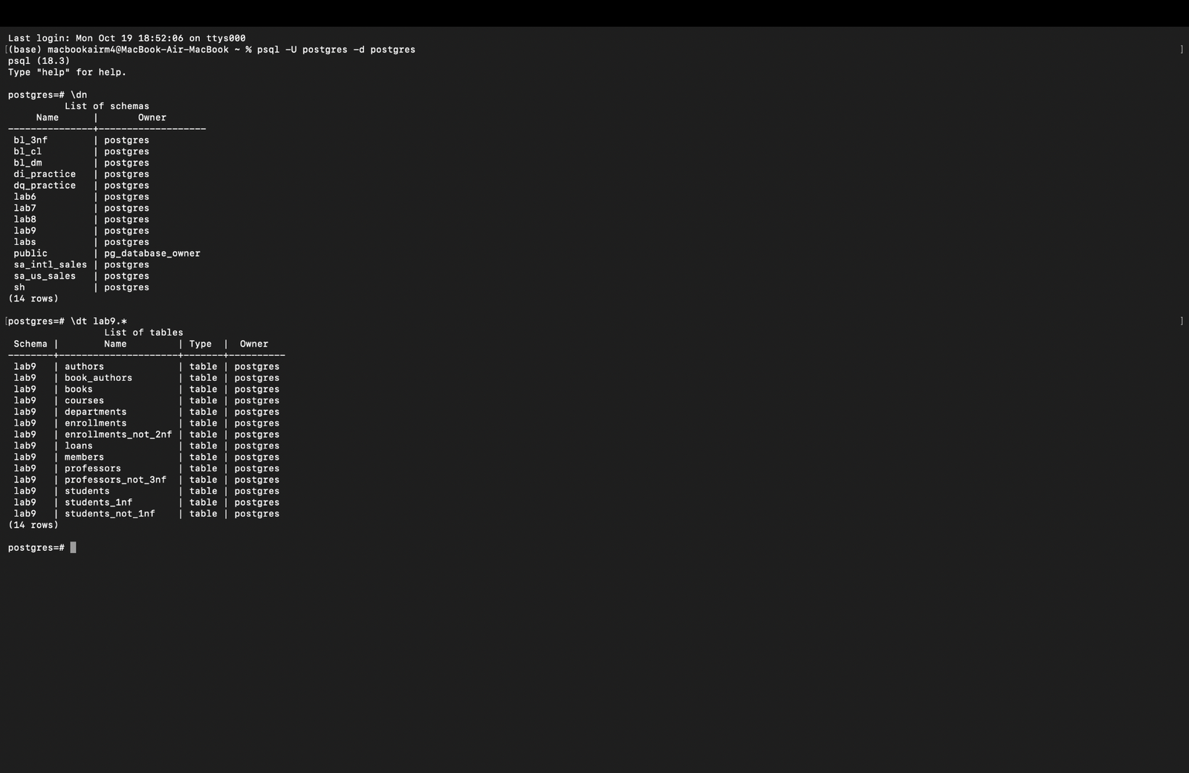

Step 3. Switch to the lab9 schema and use plain \dt
SET search_path TO lab9;
\dt

Part 2. \d: describe a table

Step 4. Describe the books table
Shows columns, data types, defaults, the primary key, UNIQUE, CHECK and which tables reference it.
Run in: PSQL Tool
\d books
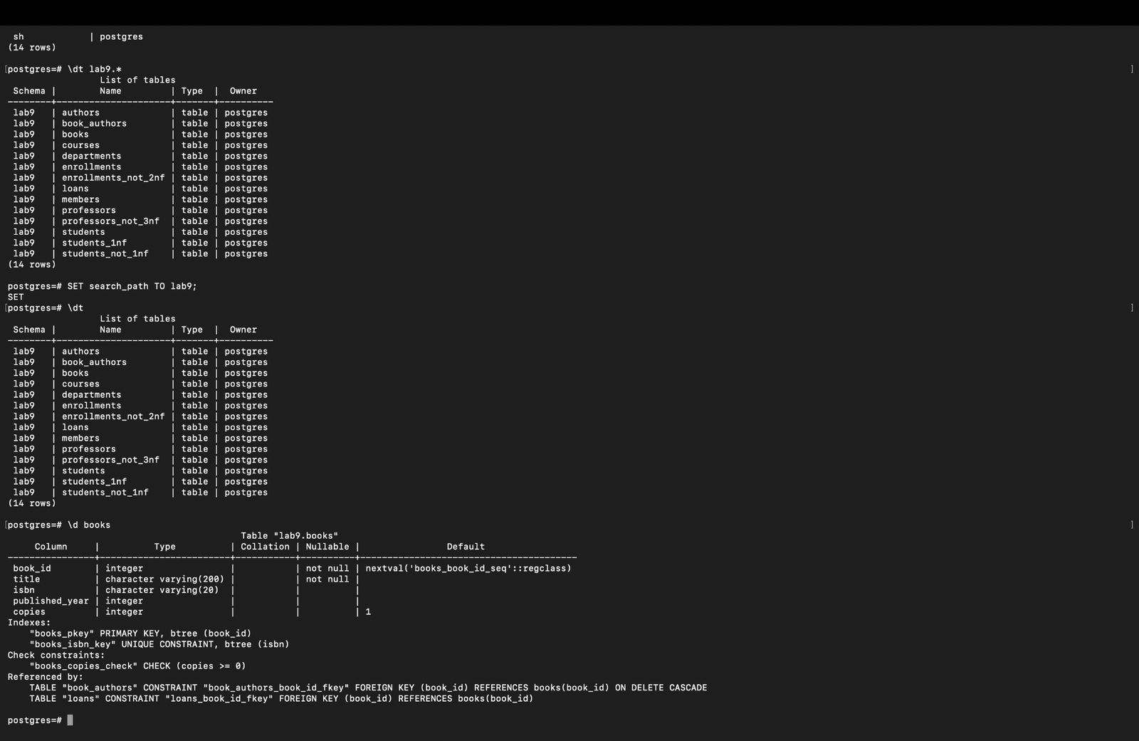

Step 5. Describe the loans table
Shows the foreign keys to books and members, and the index idx_loans_member.
\d loans
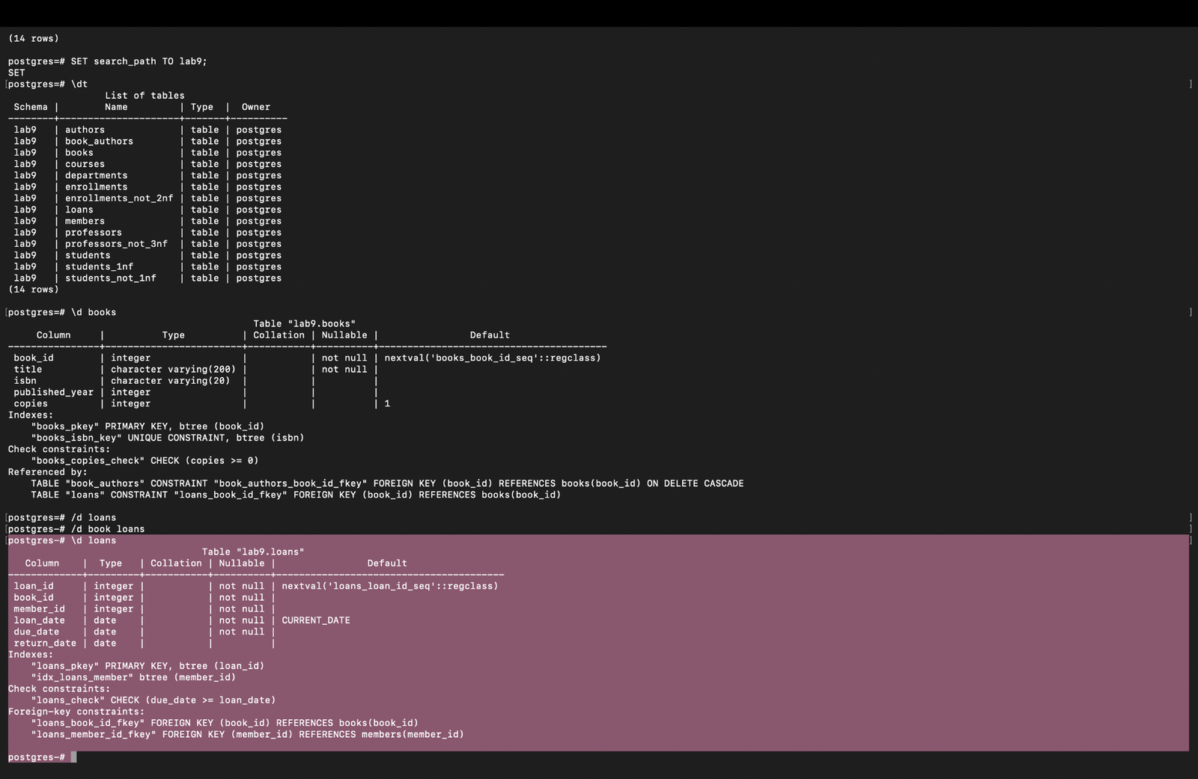

Step 6. Describe the junction table book_authors

\d book_authors
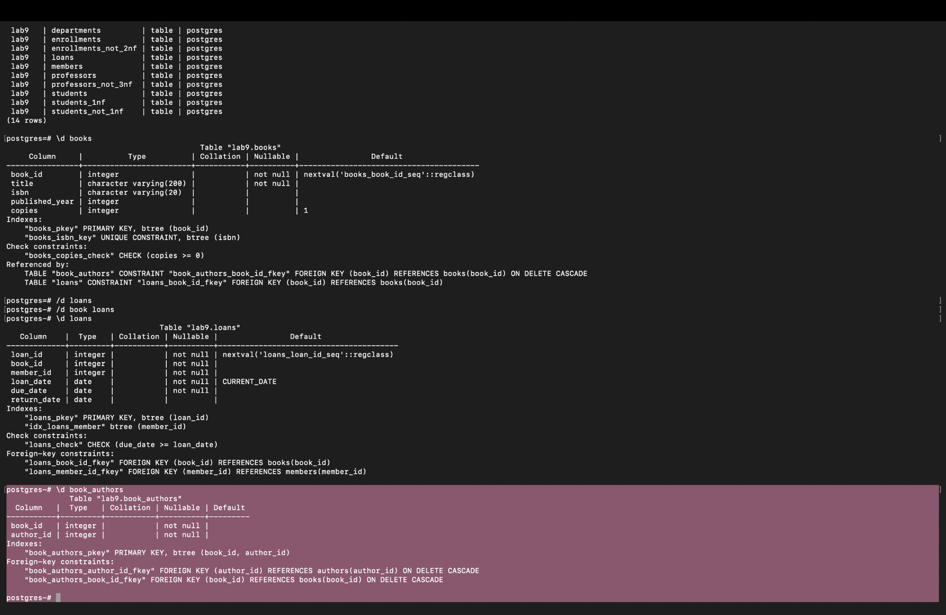

Step 7. More detail with \d+
\d+ members
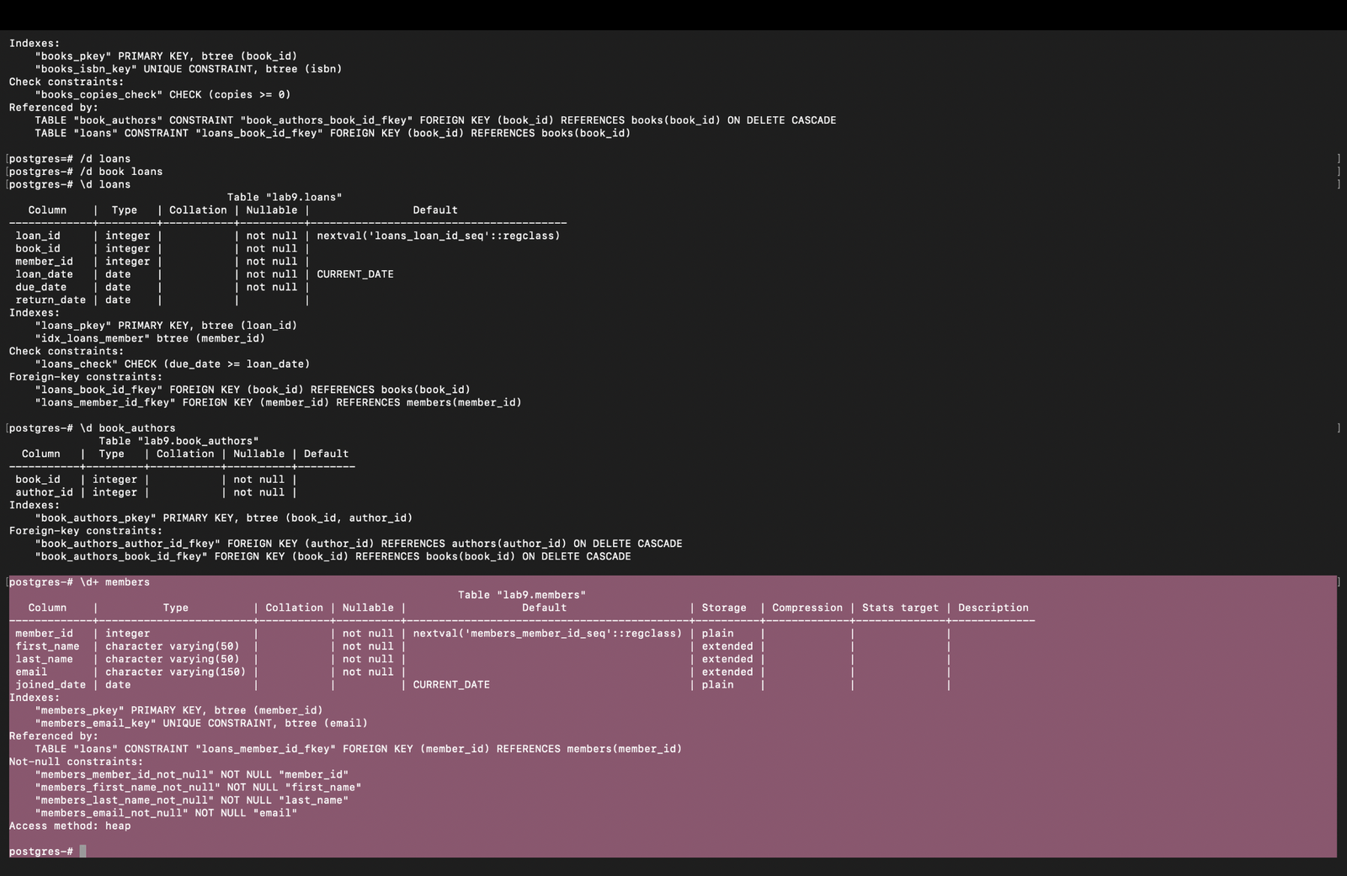

Step 8. Other useful commands
List indexes, sequences and databases.
Run in: PSQL Tool
\di
\ds
\l
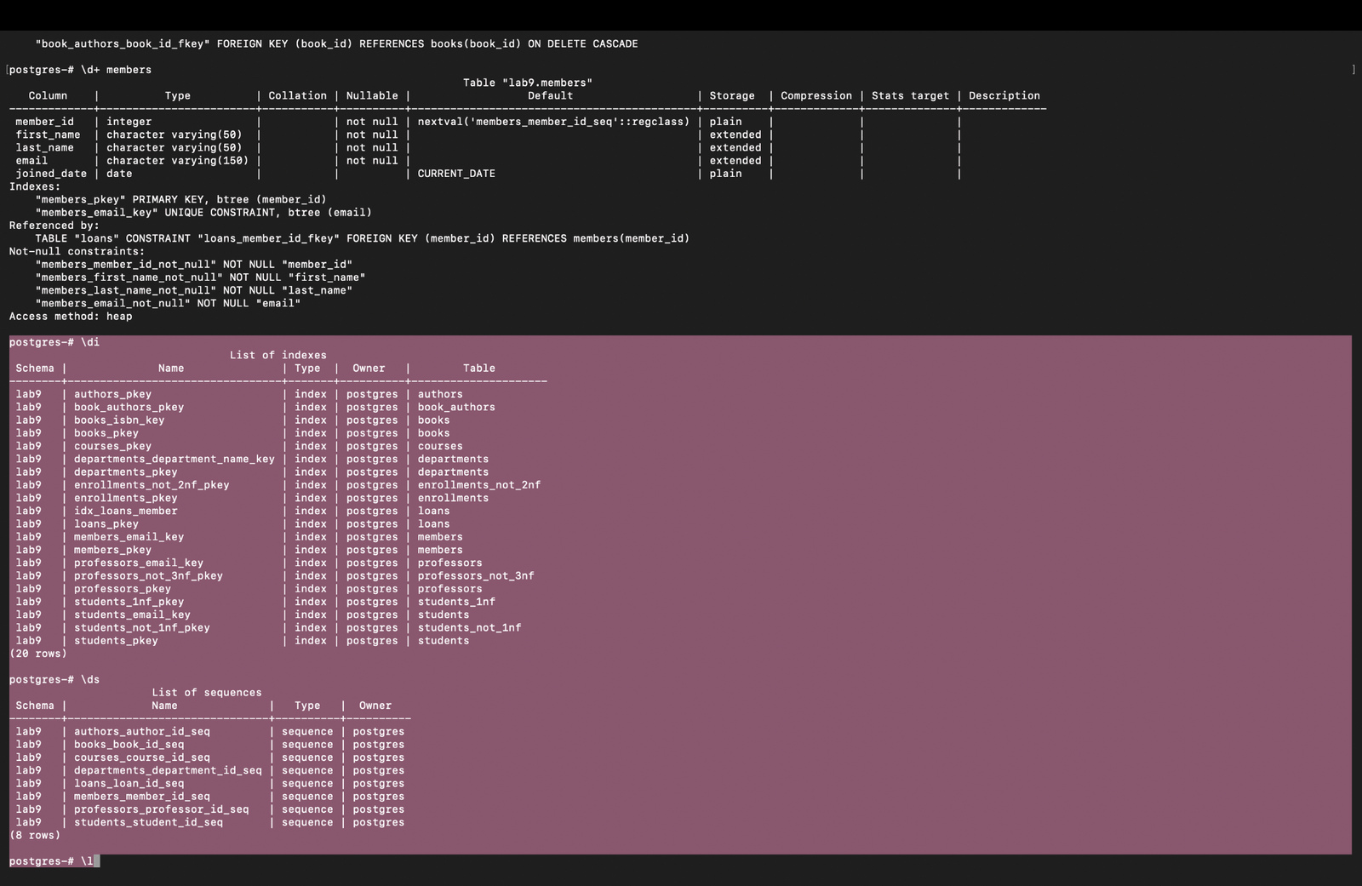

Part 3. The same information with SQL (pgAdmin Query Tool)

Step 9. Tables in a schema (like \dt)
SELECT table_name, table_type
FROM information_schema.tables
WHERE table_schema = 'lab9'
ORDER BY table_name;
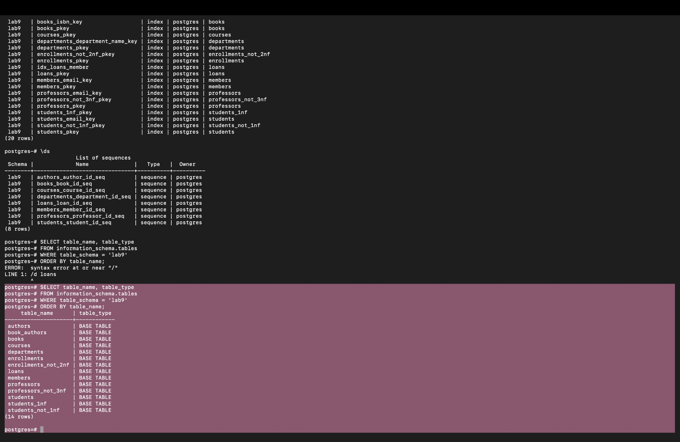

Step 10. Columns of a table (like \d)
SELECT column_name, data_type, is_nullable, column_default
FROM information_schema.columns
WHERE table_schema = 'lab9' AND table_name = 'loans'
ORDER BY ordinal_position;
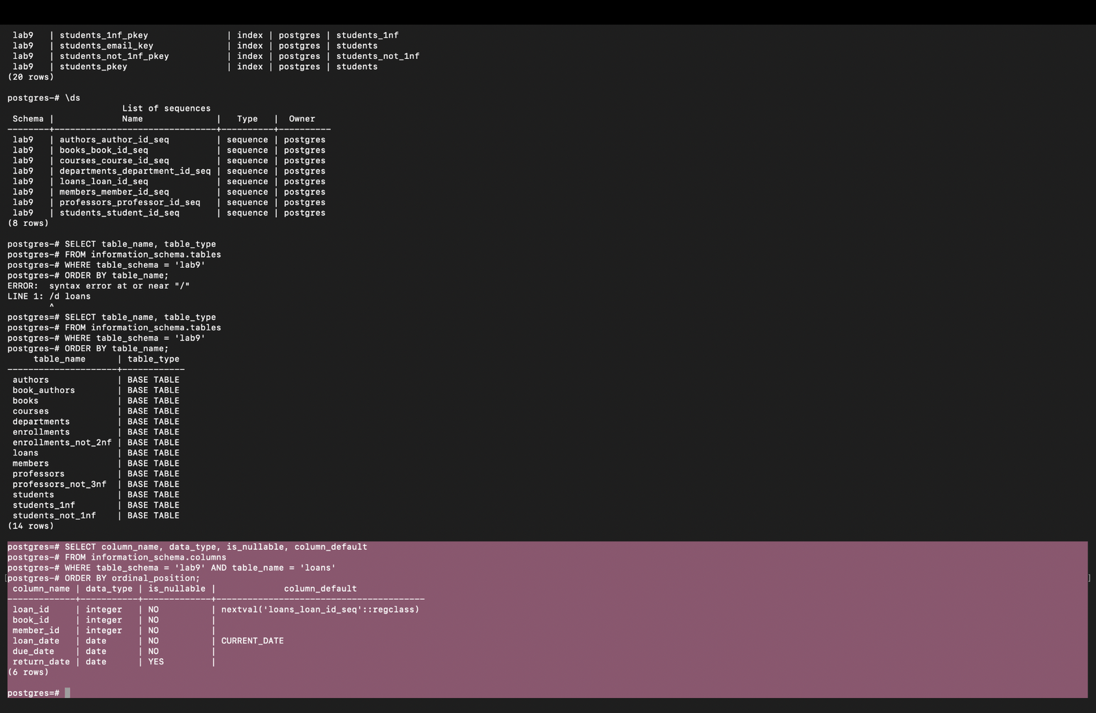

Step 11. Relationships between tables
SELECT conrelid::regclass AS child_table,
confrelid::regclass AS parent_table,
pg_get_constraintdef(oid) AS foreign_key
FROM pg_constraint
WHERE contype = 'f' AND connamespace = 'lab9'::regnamespace
ORDER BY 1;
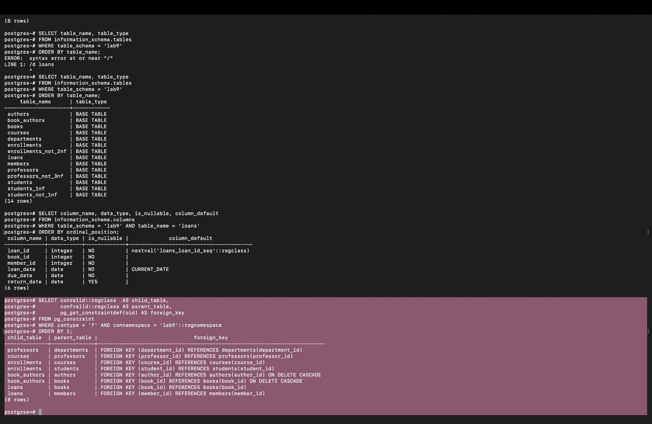

Part 4. ER diagrams in pgAdmin

Step 12. ER diagram for the whole database
Right-click your database, then ERD For Database. Zoom in on the lab9 tables so the relationship lines are visible.
